IOT BASED NOISE POLLUTION MONITORING

A project report submitted in partial fulfilled of the requirements for the degree of B.Tech-Information Technology

By

**R.REVATHI -513221205015**

Under the supervision of professor & HOD department of B.Tech-Information Technology

NOISE POLLUTION MONITORING

PHASE 1:Problem Definition And Design Thinking

* Problem Statement
* Design Thinking Approach

PROBLEM STATEMENT:

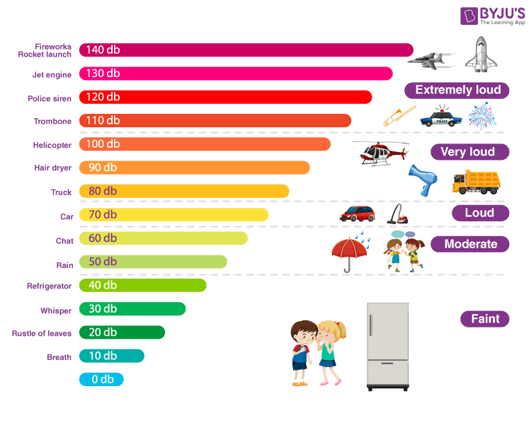

Noise pollution can cause health problems for people and wildlife, both on land and in the sea. From traffic noise to rock concerts, loud or inescapable sounds can cause hearing loss, stress, and high blood pressure. Noise from ships and human activities in the ocean is harmful to whales and dolphins that depend on echolocation to survive.

DESIGN THINKING APPROACH:

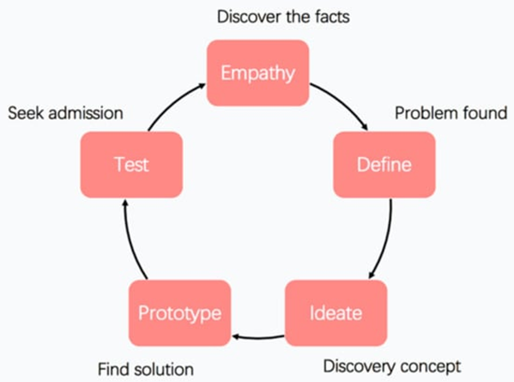

Noise pollution which is considered as the second most hazard environmental type of pollution after has been increasing day by day due to rapid urbanization and industrialization. In this noisy life situation, people try to access calm areas to take fresh breath. Directive 2002/49/EC implying the assessment and management of environmental noise confirmed the need for preventing or reducing noise levels that may negatively affect human health, including annoyance and sleep disturbance. In addition, it emphasizes the need to preserve quiet areas. However, in spite of the attempts to develop the criteria for identification of quiet areas, there is still no common guide. This leads “soundscape concept mainly focusing on how people perceive the acoustic environment” as an alternative method to be able to use in defining quiet areas in urban places. In this study, the point of soundscape concept in environmental noise control and approaches used to determine the soundscape perception which is a hot topic in recent scientific researches especially in European countries were reviewed. Moreover, the current situation of research trends in noise pollution in Turkey was investigated by conducting bibliometric and content analysis. According to the preliminary results based on Web of Knowledge and Scopus database, the major part of the studies have focused on transportation and industrial facilities with the percentage of 37% and 16% respectively.. Moreover, when taking into account of the assessment method, it was found that 48% of the studies were based on sound level measurement and modeling, and approximately %20 was related to the noise exposure and annoyance. The other point to be attracted is that researches are not necessarily concentrate on soundscape concept. This shows that the soundscape concept will become a potential study area especially on defining the quiet areas required to be determined also according to Turkish Environmental Noise Regulation. Keywords: Bibliometric analysis, Noise directive, Quiet area, Urban planning.